1. **If someone explain the project shortly ...how can someone do this...**

"**Travel Route Suggestion Based on Pattern of Travel and Difficulties** is a smart travel assistant system designed to recommend the best possible route between two places. It combines the **A* (A-Star) algorithm** to find the shortest and most efficient paths, with **machine learning** techniques that analyze historical travel data, user preferences, and route difficulties such as traffic congestion or road conditions. The system uses a relational database to store route information, user travel patterns, and difficulty scores. By learning from past user behavior and feedback, it continuously improves its suggestions to provide more accurate and personalized route planning.

**PROJECT OVERVIEW:**

The project centers on developing a "Travel Route Suggestion System Based on Patterns of Travel and Difficulties." This system aims to provide travelers with personalized route recommendations. It does this by:

* Analyzing past travel behavior.
* Predicting potential challenges along routes.
* Using data-driven insights.
* Considering user preferences and contextual factors.

The goal is to suggest routes that align with user interests, abilities, and risk tolerance.

**II. Motivation and Problem**

* Traditional route-planning tools often fail to provide personalized recommendations.
* Travelers seek routes that match their preferences, abilities, and desired adventure levels.
* There's a need to address challenges like unexpected difficulties and inefficient routes.

**III. Proposed Solution**

The project proposes an intelligent system that:

* Learns from traveller experiences.
* Considers factors like road conditions, weather, and traffic.
* Recommends routes based on user preferences and travel patterns.

**IV. Data**

The system uses several datasets:

* **Travel Data:** Information about routes, distances, etc. (e.g., df1, distance_df)
* **User Data:** User preferences and ratings. (e.g., df2, rating_df)
* **Place Data:** Details about places of interest. (e.g., df3, place_df)

These datasets are loaded using Pandas.

**V. Algorithms**

The project employs various algorithms:

* **K-Means Clustering:** Groups places with similar characteristics. The Elbow Method helps find the optimal number of clusters.
* **A* Algorithm:** Finds the most efficient path between points.
* **User-Based Recommendation:** Recommends based on similar user preferences.   .

**VI. Implementation**

* **Data Preprocessing:**
  + Merging dataframes.
  + Handling missing values.
  + Encoding categorical features.
  + Scaling numerical features.
* **Database:**
  + MySQL database is used.
  + SQLAlchemy and pymysql are used to interact with the database.
  + Tables (Places, Ratings, Distances) are created to store data.
  + Data is loaded from Pandas DataFrames into the database.
* **Recommendation Generation:**
  + The system suggests places similar to a target place based on clustering.
  + It calculates distances and suggests transport modes.

**IMPLEMENTATION:**

**1. Data Loading and Inspection**

* The implementation starts by loading datasets from CSV files using the Pandas library.
* Three datasets are loaded:
  + df2: Contains user ratings data.
  + df1: Contains travel/distance data.
  + df3: Contains place information.
* The code then uses df.head() and df.count() to inspect the first few rows and the size of the DataFrames. This helps to understand the structure and content of the data.

**2. Data Preprocessing**

* **Merging DataFrames:** The df DataFrame is created by merging df2 (ratings) and df3 (place information) on the "Place_Id" column using a left merge. This combines user ratings with details about the places.
* **Handling Missing Values:** The code checks for and drops missing values from the merged DataFrame using df.dropna().
* **Encoding Categorical Variables:** Categorical features (e.g., Place_name, Age, Category, Mode_of_Transport) are converted into numerical data using one-hot encoding with pd.get_dummies(). This is necessary for many machine learning algorithms.
* **Feature Scaling:** Numerical features in the encoded DataFrame (df_encoded) are scaled using StandardScaler to have zero mean and unit variance. This is important to ensure that features with larger ranges do not dominate the clustering process.

**3. Clustering**

* **Elbow Method for Optimal K:** The Elbow Method determines the optimal number of clusters (k) for K-Means clustering.
  + The code calculates the within-cluster sum of squared errors (SSE) for different values of k (from 1 to 9).
  + It then plots the SSE against the number of clusters to visualize the "elbow" point, which indicates the best k.***
* **K-Means Clustering:** K-Means clustering is performed on the scaled data (X_scaled) with the chosen number of clusters (in the example, k=4).
  + The cluster assignments are added as a new column ("Cluster") to the original DataFrame (df).

**4. Recommendation Generation**

* **Recommendation Logic:** The code provides an example of how to generate place recommendations.
  + It selects a target place (e.g., "Howrah Bridge").
  + It identifies the cluster to which the target place belongs.
  + It then recommends other places that are in the same cluster as the target place.
* **Distance Calculation and Transport Suggestion:**
  + The code calculates the distances between the target place and the recommended places using the geodesic distance formula.
  + It suggests the mode of transport based on the calculated distance (Walk, Auto/Rickshaw, Cab, or Metro/Bus).
* **Top-K Recommendations and Precision:**
  + The code selects the top-k recommendations (e.g., top 5) based on distance.
  + It calculates precision@k, which measures the proportion of relevant recommendations in the top-k list.

**RECOMMENDATION PART(How its work):**

**Recommendation Logic: Step-by-Step:**

1. **Select a Target Place:**
   * The process begins by choosing a specific place for which recommendations are desired (e.g., "Howrah Bridge").
2. **Identify the Target Place's Cluster:**
   * The system determines the cluster to which this target place belongs. This is crucial because the core idea is to recommend places similar to the target place, and similarity is defined by cluster membership.
3. **Find Places in the Same Cluster:**
   * The system then identifies all other places that are part of the same cluster as the target place. Importantly, the target place itself is excluded from the recommendations.
4. **Calculate Distances:**
   * For each of the places identified in the same cluster, the geographical distance from the target place is calculated. \*\***The geodesic** distance formula is used to compute accurate distances between latitude and longitude coordinates.
5. **Suggest Transport Mode:**
   * Based on the calculated distances, the system suggests appropriate modes of transport.
     + For very short distances (less than 1 km), "Walk" is suggested.
     + For short distances (less than 5 km), "Auto/Rickshaw" is recommended.
     + For medium distances (less than 20 km), "Cab" is suggested.
     + For longer distances, "Metro/Bus" is recommended.

1. **Determine Top-K Recommendations:**
   * The system selects the top-k recommendations, where 'k' is a predefined number (e.g., 5). These are the closest places (or the top 5 closest places) to the target place within the same cluster.
2. **Assess Recommendation Relevance:**
   * The system evaluates the relevance of the top-k recommendations. In the provided code, a recommendation is considered "relevant" if its user rating is above a certain threshold (e.g., 4.0).
3. **Calculate Precision@k:**
   * Precision@k is calculated to measure the accuracy of the top-k recommendations. It's the proportion of the top-k recommendations that are considered "relevant".
4. **Present Results:**
   * The final output is a structured presentation of the recommended places, including details like:
     + Place name
     + Category
     + Distance from the target place
     + User rating
     + Suggested mode of transport
     + An indication of whether the recommendation is considered "relevant"

**Why encoding need?**

**Why Encoding is Necessary\*\*\***

* **Machine Learning Algorithms and Numbers:** Most machine learning algorithms are designed to work with numerical data. They perform mathematical operations (like calculating distances, finding patterns, etc.) on numbers.
* **Categorical Data is Different:** Categorical data, on the other hand, represents categories or labels (e.g., "Place_name" like "Howrah Bridge", "Category" like "Historical Site", "Mode_of_Transport" like "Cab"). These are not numbers in the mathematical sense.
* **Need for Conversion:** Therefore, we need to convert categorical data into a numerical format so that machine learning algorithms can process it.

**Why One-Hot Encoding is Used in This Project:**

In your travel route suggestion project, One-Hot Encoding is specifically used to handle categorical data within the datasets to make it suitable for use in machine learning algorithms, particularly the K-Means clustering algorithm.

* **Categorical Features in Travel Data:** The travel datasets contain categorical features such as:
  + Place_name (e.g., "Victoria Memorial," "Howrah Bridge")
  + Category (e.g., "Historical Monument," "Shopping, Entertainment")
  + Mode_of_Transport (e.g., "Bus, Taxi," "Metro")
  + Age
* **K-Means and Numerical Data:** The K-Means clustering algorithm, which is used to group places with similar characteristics, requires numerical input. It calculates distances between data points, and this calculation is only possible with numbers.
* **Converting Categories to Numbers:** One-hot encoding transforms these categorical features into a numerical format. Each unique category becomes a binary column (0 or 1), indicating the presence or absence of that category for a given data point.
* **Example:** For "Mode_of_Transport," one-hot encoding creates columns like "Mode_of_Transport_Bus," "Mode_of_Transport_Taxi," "Mode_of_Transport_Metro," etc. A place accessible by "Bus and Taxi" will have 1s in the "Bus" and "Taxi" columns and 0s in others.
* **Benefits for the Project:**
  + It enables the use of categorical data in the K-Means algorithm to cluster places based on their attributes.
  + It prevents the algorithm from misinterpreting categorical data as having a numerical order or scale.
  + It creates a more informative dataset for the algorithm to identify patterns and similarities between places.

**DISTANCE CALCULATION:**

The code you've provided primarily uses the **geodesic distance** for calculating the distance between recommended places and a target place.

* **Geodesic Distance:** This is the shortest distance between two points on the surface of a sphere (or ellipsoid, which is a more accurate model of the Earth). It's calculated using latitude and longitude coordinates, which are essential for accurate travel recommendations.
* **Implementation:** The geodesic function from the geopy.distance library is used. This function takes the latitude and longitude of two points as input and returns the distance between them.
* **Purpose:** This distance calculation is used to:
  + Sort recommendations by proximity to the target place..
  + Suggest appropriate modes of transport based on the distance.

**If the project were to implement full route planning (finding a sequence of places to visit), then A* could come into play. A* would use a more sophisticated "cost" calculation, potentially incorporating the geodesic distance between places, road information, and other factors, to find the optimal route.\*\*\***

**A* WORK:**

The A* (A-Star) algorithm is an intelligent pathfinding algorithm used to determine the shortest and most efficient route between two graph points, such as travel map locations. It works by combining the strengths of Dijkstra’s algorithm and Greedy Best-First Search through a cost function f(n) = g(n) + h(n), where g(n) represents the actual cost from the start node to the current node, and h(n) is a heuristic estimate of the cost from the current node to the goal. This balance allows A* to explore paths that are both efficient and likely to reach the goal quickly. One of its main advantages is that it guarantees an optimal path if the heuristic is accurate and does not overestimate. Compared to algorithms like Dijkstra's (which doesn’t use heuristics and explores blindly), A* is significantly faster and more focused. Unlike Greedy Best-First Search, which may find suboptimal paths, A* ensures both optimality and efficiency, making it ideal for travel route planning and navigation systems.

**why clustering is used in the project........why not another approach? What is the importance to use this**

Clustering, and in this case, K-Means, is used in your project primarily for **grouping places of interest based on their similarities.** This grouping is fundamental to the recommendation strategy. Here's a more detailed explanation:

* **Identifying Similar Places:**
  + The core idea is that travelers often seek out places similar to those they've enjoyed before.
  + Clustering helps to automatically identify these similarities in an unbiased way.
  + Instead of relying on manual categorization (which can be subjective and incomplete), clustering algorithms find patterns in the data to group places.
* **Features for Similarity:**
  + The clustering algorithm uses various features to determine similarity. These features are derived from the data and can include:
    - Place category (e.g., historical site, restaurant, park)
    - User ratings
    - Location
    - Other attributes encoded from the dataset
* **Recommendation Strategy:**
  + Once places are grouped into clusters, the recommendation strategy becomes straightforward:
    - If a user shows interest in a place, the system recommends other places within the same cluster.
    - The assumption is that places in the same cluster are likely to share characteristics that the user will find appealing.

Clustering, specifically K-Means, is employed in this project as a foundational step to group places with similar characteristics based on the available data, including user ratings and potentially encoded categorical features. This approach allows for an automated and data-driven identification of place similarities, going beyond manual categorization which can be subjective and less comprehensive. While other recommendation techniques like content-based or collaborative filtering could be used, clustering offers a valuable initial segmentation of the place landscape. It enables the system to suggest places within the same cluster as a user-preferred location, assuming.shared characteristics appeal to the user. This method is relatively scalable and can provide meaningful recommendations even with a moderate amount. **

**main diffenece this proejct what we do vs GOOGLE MAP:**

The key difference between our Travel Route Suggestion project and Google Maps lies in their purpose, data handling, and functionality. Our project is an academic prototype designed to recommend the best travel path using the A* algorithm and predict route difficulty (Easy, Medium, Hard) using the K-Nearest Neighbors (KNN) algorithm. It relies on a static, pre-defined dataset of locations and travel conditions, focusing on combining route optimization with difficulty classification. In contrast, Google Maps is a real-time, large-scale navigation tool that uses live GPS data, traffic updates, user behavior, and advanced algorithms like A*, Dijkstra, and machine learning models to provide accurate, real-time route suggestions, ETAs, and traffic conditions. While our system recommends the most suitable route based on predefined factors, Google Maps dynamically updates suggestions based on road closures, accidents, and traffic flow. Additionally, our system is limited in scale and does not integrate with real-time services or APIs, whereas Google Maps offers full integration with mobile devices, voice input, and various real-time services. Overall, our project serves as a conceptual demonstration of intelligent route planning with added difficulty analysis, while Google Maps is a robust, real-world solution for everyday travel needs**.**

**Our Project's Key Focus:** Personalized travel route suggestions based on patterns of travel and difficulties, potentially incorporating user ratings and preferences for specific places. The project uses techniques like clustering to group similar places and might aim to predict route difficulties based on data.

**Google Maps' Key Focus:** Primarily a navigation tool providing efficient routes, real-time traffic information, and location discovery for a wide range of points of interest. 1 While it offers different transportation modes, it doesn't inherently focus on deep personalization based on past travel patterns or explicit prediction of route difficulties in the way your project seems to aim…

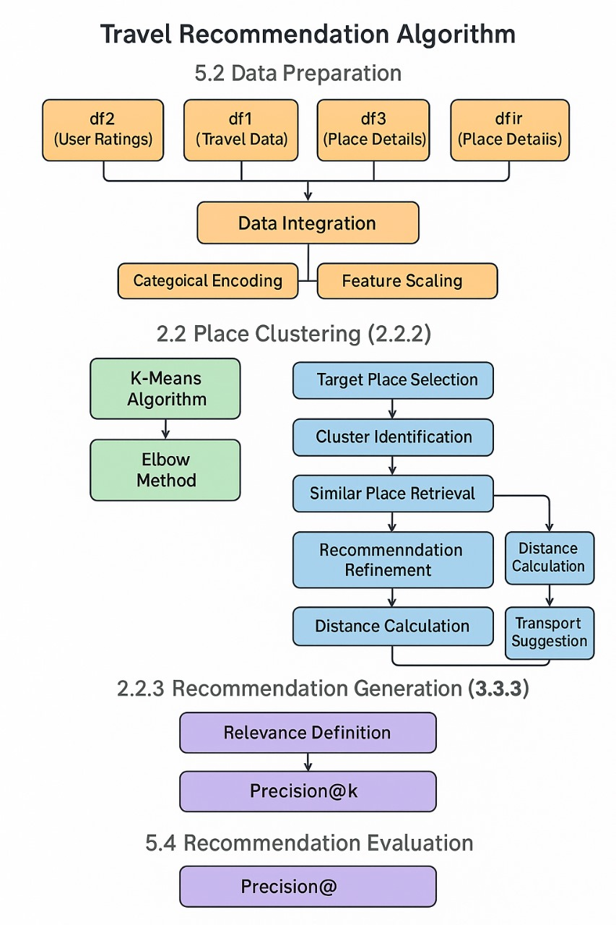

PRECISIONk calculate:

Precision@k is a metric used to evaluate the accuracy of a recommendation system when providing a ranked list of recommendations. It measures the proportion of the top-k recommendations that are relevant to the user.

Here's a breakdown:

* **Top-k Recommendations:** When a recommendation system generates a list of suggestions, it typically presents only the top 'k' items to the user (e.g., the top 5, top 10).
* **Relevance:** To calculate precision, you need to define what "relevant" means. In your project, a recommendation is considered "relevant" if the place has a user rating above a certain threshold (e.g., 4.0).
* **Calculation:**
  + Count how many of the top-k recommended places are "relevant."
  + Divide that count by 'k'.

**Example:**

Let's say your system recommends 5 places (k=5), and 4 of them have a user rating of 4.0 or higher.

Precision@5 = 4 / 5 = 0.8

This means that 80% of the top 5 recommendations were considered "relevant."

**Importance:**

Precision@k is important because it tells you how often the system's top recommendations are actually useful to the user. A higher precision@k indicates that the system is good at suggesting relevant items.

**explain backend and fronted part shortly ..what i do:**

**User → Webpage (HTML) → Flask Backend → Data Processing + A + ML → Recommendations → Webpage\***

**🧠 STEP-BY-STEP PROCESS:**

**🔹 STEP 1: Setup Dataset into database and Flask API (Backend)**

* Create database in jupyter using PYMYSQL
* Prepare features like:
  + Place_name, Category, Age, Distance_km, Rating, Mode_of_Transport
* Create a **graph structure** using NetworkX or custom Python dicts to represent places and connections.

**🔹 *STEP 2: Implement A Algorithm for Route Planning*\***

* Define a graph of all places and their connections.
* Use A* (A-Star) algorithm to find the **optimal path** from the selected place to others based on distance or cost.
* This ensures that recommendations are **geographically reachable and optimized**.

**🔹 STEP 3: Machine Learning Model (Optional)**

* You might use a basic **recommendation logic** or **ML model** (like decision tree or regression).
* It uses inputs like:
  + User’s age
  + Travel distance
  + Rating of place
* Predicts a **score or rating** for each potential place.

**🔹 STEP 4: Flask Endpoints**

You created two key API routes:

1. **/places**
   * Returns list of all unique places in JSON
   * Used to populate the dropdown in frontend
2. **/recommend?place=XYZ**
   * Accepts a selected place as input
   * Applies A* + ML logic
   * Returns a JSON list of top 5 recommended places with relevant details

**🔹 STEP 5: Frontend (HTML + JS)**

* A basic **HTML page** with:
  + Dropdown to choose a place
  + Button to trigger recommendation
  + Table to show output
* JavaScript does the following:
  + On page load → fetches /places → populates dropdown.
  + On button click → sends request to /recommend?place=XYZ
  + Parses the returned data and fills the result table dynamically

**🔹 STEP 6: Output Recommendations**

Each recommendation shows:

* Recommended Place
* Category
* Age
* Distance
* Rating
* Mode of Transport
* Suggested Transport
* Whether it's **relevant (Rating ≥ 4.0)**

**✅ FINAL RESULT:**

**User selects a place → Backend calculates best travel paths → ML model ranks them → Top 5 places are shown on the frontend table.\*\*\***

Flask plays a central role in your travel recommendation project by acting as the backend server that connects your recommendation logic to the frontend interface. It provides a lightweight and flexible web framework in Python, allowing you to define various routes (URLs) that perform specific functions, such as sending the list of available travel places (/places), calculating recommendations based on a selected location (/recommend), and managing user ratings. When the frontend (HTML page) is loaded, Flask serves it to the browser using render_template. JavaScript embedded in the HTML uses fetch() to send requests to the Flask server. For example, when a user selects a location and clicks "Get Recommendations", a request is sent to the /recommend endpoint. Flask receives this request, runs the recommendation logic (which involves fetching data from a database, calculating distances using geopy, merging ratings, and sorting by relevance), and returns the top 5 recommended places in JSON format. The frontend then dynamically updates the results table using the data returned. Flask also uses the SQLAlchemy connector to interact with the database, where place names, distances, ratings, and other related data are stored. Overall, Flask seamlessly integrates the backend logic and data with the frontend interface, enabling a smooth and interactive travel recommendation system.

Here are the **key focus points** of how Flask helps in your travel recommendation system:

1. **Backend Framework**: Flask provides the foundation to build your backend in Python, handling all server-side logic.
2. **Routing**: It defines API endpoints like /places and /recommend to serve place names and recommendations to the frontend.
3. **Request Handling**: Receives requests (e.g., selected place) from the frontend and processes them.
4. **Data Processing**: Executes recommendation logic (distance, rating, age relevance) and formats results as JSON.
5. **Database Interaction**: Connects with the database to fetch and merge travel data, using libraries like SQLAlchemy or pandas.
6. **Communication Bridge**: Acts as a bridge between your HTML frontend (JavaScript fetch) and Python logic.